Comms Framework API

Security Classification: | Confidential
Document Reference: | N/A
Status: | Issued
Version: | 1.5
Team/Department : | Core/Networking
Author(s): | Patrik Bannura
Owner(s): | Networking TA

Approver(s): | Klaus Nielsen, Thomas Goodfellow, Philippe Gabriel | Distribution: | Klaus Nielsen, Thomas Goodfellow, Philippe Gabriel

Contents
1 Introduction 3
1.1 Purpose and Scope 3
2 Design Overview 3
3 Detailed Design 3
3.1 Modules 3
3.1.1 Startup 3
3.1.2 Submodules 4
3.2 Asynchronous Messages 4
3.2.1 Class Diagram 4
3.2.2 Code 5
3.2.3 TCFMessage API 5
3.3 Comms Channel 5
3.3.1 RCFChannelBase API 6
3.3.2 RCFChannel API 7
3.4 General Messages 7
3.4.1 Bind 7
3.4.2 BindComplete 8
3.4.3 Unbind 8
3.4.4 UnbindComplete 9
3.4.5 Discover 9
3.4.6 DiscoverResp 9
3.4.7 Forward 10
3.4.8 Shutdown 10
3.4.9 PIG 10
3.5 CCFModuleChannelHandler 10
3.6 RCFThread 10
4 Other considerations when designing around channels 12
4.1 Object lifetime and ownership 12
4.1.1 Explicit transfer of ownership 12
4.1.2 The lesser kind of “bad” 12
4.2 Closing channels in a safe manner (avoiding orphaned data) 12
4.2.1 Standard paired-channel implementation 13
5 Further Information 14
5.1 People 14
5.2 References 14
5.3 Open Issues 14
5.4 Glossary 14
5.5 Document History 14
5.6 Document Review Date 15

Introduction

Purpose and Scope
The purpose of this document is to describe the design of the general comms framework, the asynchronous message queues aka “Comms Channels” and the general messages used in the comms process.

Design Overview
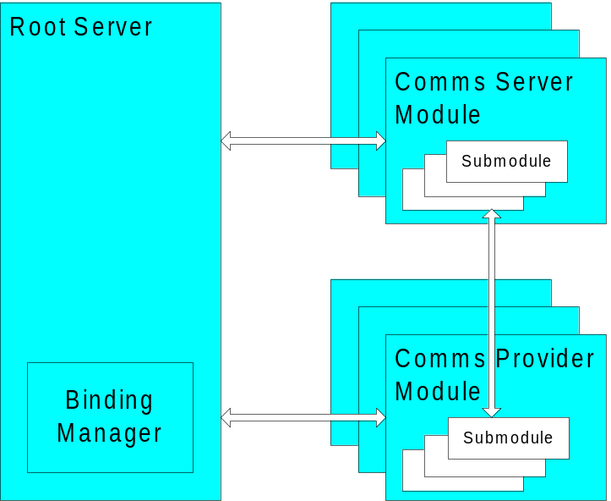

The components in the Comms process communicate via asynchronous messages.

Detailed Design

Modules

Startup
A CPM thread is started by having its main thread function called. The argument is a void* that should be cast to
struct
{
RCFChannel aInputCommsChannel; // A general comms channel for incoming messages
RCFChannel aOutputCommsChannel; // A general comms channel for outgoing messages
HBufC* aIniData; // Initialisation data specific to the module. Free’d by the module
};

The general CommsChannels passed in are created and owned by the Binding Manager.
The contents of the initialisation data parameter (aIniData) is specific to the module. It could be empty, contain the contents of an associated INI file or contain some other data specified by the specific module implementation.

Submodules

Both Server Modules and Provider Modules may contain submodules. They have no channels to the Binding Manager but they can be requested to bind to other modules or submodules by the Binding Manager.

Asynchronous Messages
Each channel has a specified (maximum) message size, where the maximum size of a message supported by the kernel is 256 bytes, and messages of eight bytes or less are expected to be particularly more efficient to send (depending on the kernel implementation on the particular platform). Because the memory consumed for each queue in a channel is the product of the specified message size and the number of message slots there is a further good reason to try to minimise the size - for more data or data of unspecified size an RMBufChain (and its ownership) should be passed.
Every general message consists of a message header and a number of parameters. The header contains an operation code. The header uses 4 bytes and each parameter is of fixed size but specific to each message. Variable size parameters are not allowed. This is to be able to determine the maximum size of every message type.
For private messages this format may be overriden but every message type must be derived from TCFMessageBase.
Note that the messages don’t contain addressing information.

TCFMessage:
Parameter n

Parameter 1

Header

Header:
Code

Class Diagram
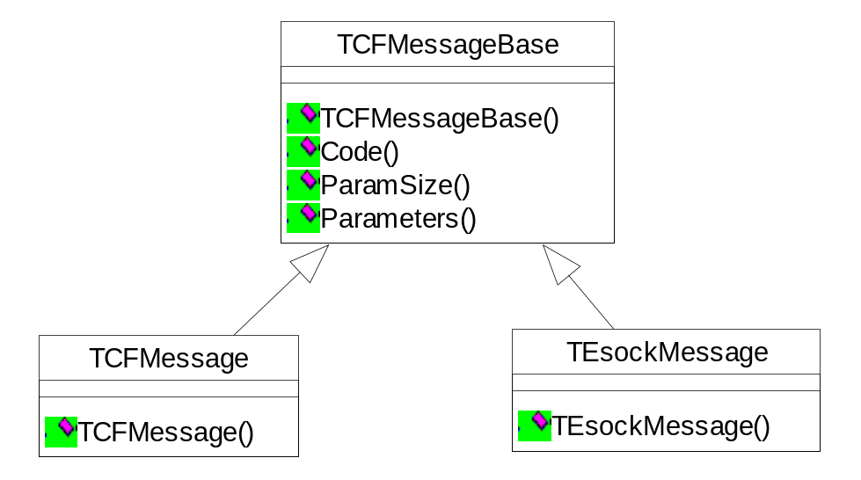

Code
The message code identifies an operation uniquely.
enum TCode
{
ECodeBind,
ECodeBindComplete,
ECodeUnbind,
ECodeUnbindComplete,
ECodeDiscover,
ECodeDiscoverResp,
ECodeShutdown
ECodeForward
};

TCFMessage API

TCFMessage
TCFMessage::TCFMessage(TCode aCode, TInt aParamSize, TAny* aParamBlock)
Creates a TCFMessage with command code aCode. The size of aParamBlock is aParamSize bytes. The parameter pointed to by aParamBlock will be copied into the message. aParamSize must be small enough for the parameter block to fit in the message.

TCFMessage::TCFMessage()
Creates an empty message with undefined contents.

Code()
TCode TCFMessage::Code() const
Returns: the command code.

ParamBlockSize()
TInt TCFMessage::ParamBlockSize() const
Returns: the size of the parameter block in bytes

ParamBlock()
TAny* TCFMessage::ParamBlock() const
Returns: a pointer to the parameter block

Comms Channel
A Comms Channel is a unidirectional message passing pipe for asynchronous communication between Comms modules. Internally it contains a number of message queues (one for each priority); one for the general RCFChannel but this may be overridden by the derived private Comms Channels. More than one queue will be necessary for modules that need to prioritise between messages.
Comms Channels are “peer-to-peer”, i.e every channel has only one producer and one consumer. Also, every two endpoints that need to communicate over a module or submodule boundary need to have a dedicated comms channel in each direction.
All comms channels have to be derived from RCFChannelBase.

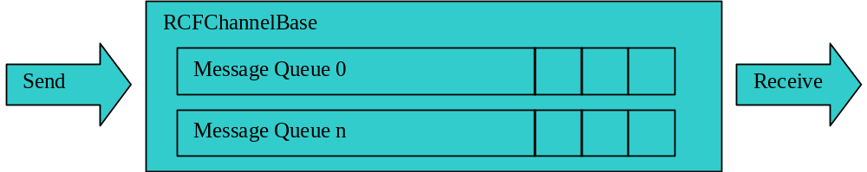

It has two ends; one for reading and one for writing. The API will guarantee that messages of higher priority will be read first.

RCFChannelBase API
This is a templated class:
template<class aMsg, TInt aNumberOfQueues> class RCFChannelBase
RCFChannelBase is not meant to be instantiated.

RCFChannelBase ()
RCFChannelBase::RCFChannelBase(TInt aMessageSlots)
Constructor. The queues will each hold a maximum of aMessageSlots messages. Higher numbered queues have higher priority.

Send()
TInt RCFChannelBase::Send(const TCFMessageBase& aMsg, TInt aQueue)
Syncronously send a message over queue aQueue.
Returns: KErrNone if the message was sent, KErrOverflow if the queue is full, KErrArgument if the message code is invalid.

NotifySpaceAvailable()
void RCFChannelBase::NotifySpaceAvaliable(TRequestStatus& aStatus, TInt aQueue)
aStatus is signalled when a message can be sent.

CancelSpaceAvailable ()
void RCFChannelBase::CancelSpaceAvailable(TInt aQueue)
Cancel a NotifySpaceAvailable(). This is only meaningful if a NotifySpaceAvailable is pending.

Receive()
TInt RCFChannelBase::Receive(TCFMessageBase& aMsg)
Syncronously receive a message from the RCFChannel. This receives a message from the highest priority queue.
Returns: KErrNone if a message was received or KErrUnderflow if all queues are empty.

NotifyDataAvailable()
void RCFChannelBase::NotifyDataAvailable(TRequestStatus& aStatus)
aStatus is signalled when a message is available in any queue. Data in the highest priority queue is notified first.

CancelDataAvailable()
void RCFChannelBase::CancelDataAvailable()
Cancels a NotifyDataAvailable().This is meaningful only when a NotifyDataAvailable is pending.

RCFChannel API
RCFChannel is a channel with only one queue. It passes messages of type TCFMessage. See RCFChannelBase for member function documentation.
This is a templated class:
class RCFChannel : public RCFChannelBase<TCFMessage, 1>

RCFChannel ()
RCFChannel::RCFChannel(TInt aMessageSlots = 1);

Send()
TInt RCFChannel::Send(const TCFMessage& aMsg)

NotifySpaceAvailable()
void RCFChannel::NotifySpaceAvaliable(TRequestStatus& aStatus)

CancelSpaceAvailable ()
void RCFChannel::CancelSpaceAvailable()

Receive()
TInt RCFChannel::Receive(TCFMessage& aMsg)

NotifyDataAvailable()
void RCFChannel::NotifyDataAvailable(TRequestStatus& aStatus)

CancelDataAvailable()
void RCFChannel::CancelDataAvailable()

General Messages

Bind
Bind the recipient of this message to a module.

Message Code: | ECodeBind
Parameter | Type | Name | Description
Parameter 0 | TId | aIdentifier | Unique identifier so that BindComplete can refer back to this message.
Parameter 1 | TMsgQueues | aInputChannel | The message queues to receive messages from.
Parameter 2 | TMsgQueues | aOutputChannel | The message queues to write messages to.
Parameter 3 | TCFSubModuleAddress* | aModuleName | The name of the module and submodule to bind in the format “name:name”.
Parameter 4 | TCFSubModuleAddress* | aModuleName | The name of the module and submodule to bind in the format “name:name”.
Parameter 5 | TRSBindType | aType | The type of binding. May be EHierarchicalUpper, EHierarchicalLower or EHorizontal.

Bind example:

Binding Manager
M1
M2
C2
C1
Bind(C1,C2)
Bind(C2,C1)

C1 and C2 are comms channels. The Binding Manager sends a Bind request to each of the modules that will be bound.

BindComplete
Signal the initiator that the Bind operation is complete.

Message Code: | ECodeBindComplete
Parameter | Type | Name | Description
Parameter 0 | TId | aIdentifier | The identifier referring to the Bind message.
Parameter 1 | TInt | aReturnCode | KErrNone or system wide error.

Unbind
Unbind the recipient from a module.

Message Code: | ECodeUnbind
Parameter | Type | Name | Description
Parameter 0 | TId | aIdentifier | A unique identifier so that UnbindComplete can refer back to this message
Parameter 1 | TCFSubModuleAddress* | aSubModuleName | The name of the module and submodule to unbind in the format “name:name”.
Parameter 2 | TCFSubModuleAddress* | aSubModuleName | The name of the module and submodule to unbind in the format “name:name”.
Parameter 3 | TBool | aPeerIsDead | True if the module to unbind from is known to be dead.

UnbindComplete
Signal the initiator that the Unbind operation is complete.

Message Code: | ECodeUnbindComplete
Parameter | Type | Name | Description
Parameter 0 | TId | aIdentifier | The identifier referring to the Unbind message.
Parameter 1 | TInt | aReturnCode | KErrNone or system wide error.

Discover
Query for generic module information.

Message Code: | ECodeDiscover
Parameter | Type | Name | Description
Parameter 0 | TId | aIdentifier | The identifier referring to the Unbind message.
Parameter 1 | TBool | aReset | != EFalse to start discovery, EFalse to continue after a previous DiscoverResp indicated more to come
Parameter 2 | TUint | aSize | Size of the array aSubModulesName
Parameter 3 | TCFSubModuleName* | aSubModuleNames | Points to an array of sub-module names allocated by and owned by the message sender.

DiscoverResp
Return discovery information.

Message Code: | ECodeDiscoverResp
Parameter | Type | Name | Description
Parameter 0 | TId | aIdentifier | The identifier matching the request.
Parameter 1 | TInt | aReturnCode | Number of entries written to the array specified by the Discover message (ie aSubModulesName[0.. aNumberWritten – 1]
Parameter 1 | TBool | aMoreToWrite | != EFalse if discovery should continue (ie not all submodules have yet been identified and so another Discover message with aReset == EFalse should be sent

Forward
Forwards a specified message from the Rootserver to a CPM
Message Code: | ECodeForward
Parameter | Type | Name | Description
Parameter 0 | TCFModuleName* | aName | Specifies the module name the message is being send to.
Parameter 1 | TInt | aType | Determines the type of data passed via aData parameter.
Parameter 2 | TDes8* | aData | Descriptor with the data specific to the message of the type aType

Shutdown
Ask the module to shut down. No confirmation required.
Note: Unbind implicit
Message Code: | ECodeShutdown

PIG
Flush the channel. This must be the last message.
Message Code: | ECodePIG

CCFModuleChannelHandler
Utility class to help holding a channelpair, listening for incoming messages and sending responses for CPMs needing a quick way to implement support for the basic messages Discover, Bind, Unbind and Shutdown. All the virtuals have default bodies so only those that require special treatment needs implementation. Using this class for talking to the RootServer helps code re-usage and ROM savings.

RCFThread
This is an extension of the core RThread class:
class RCFThread : public RThread
It provides for the creation of threads with some key attributes pre-established. In this design these attributes are:
- The MBuf Manager registered in TLS. This provides transparent access for CPMs that use MBufs.
- The Comms Framework logger registered in TLS. This provides logging for Comms Channels in debug-supporting builds.
However in future further attributes may be added, so module implementors should make use of this class when creating additional threads even if their function does not require the current attributes.
The Create() methods has two overloads, providing a similar interface to the RThread class:
TInt RCFThread::Create(const TDesC& aName, TThreadFunction aThreadFunction, TInt aStackSize, RHeap* aHeap, TAny* aArgs);
TInt RCFThread::Create(const TDesC& aName, TThreadFunction aThreadFunction, aStackSize, TInt aMinHeapSize, TInt aMaxHeapSize, TAny* aArgs);
Parameters (see RHeap for full specification and semantics):
aName | Name to be assigned to the new thread
aThreadFunction | Execution of the new thread passes to this function after the Comms Framework attributes have been established
aStackSize | Size of the new thread’s stack
AArgs | Passed as argument to aThreadFunction
AHeap | Existing RHeap to be used by new thread
AMinHeapSize | Minimum size for newly-created heap for new thread
AMaxHeapSize | Maximum size for newly-created heap for new thread

Other considerations when designing around channels
The a-synchronicity of channels poses some specific challenges not so commonly faced with synchronous, direct-call interfaces

Object lifetime and ownership
For reasons of efficiency it will often be desirable to pass pointers across a channel, eg the names of sub-modules in a BIND request. The case of unexpectedly late dequeuing should be considered, ie what if the recipient only unpacks the message after the sender has freed those dynamic allocations, perhaps because of a sudden unloading of that module. Some possible solutions to this problem:

Explicit transfer of ownership
If the sender either no longer needs the object – such as when ESock writes data to a SAP – or can cheaply manufacture a copy of it, then the pointer can be enqueued with the explicit design that the recipient will free it.
This has to be handled with care. In the general case (sub)modules don’t necessarily share the same heap.

The lesser kind of “bad”
When evaluating design alternatives for transferring data through asynchronous queues these thoughts may be useful:
- Robustness is relative – we cannot cope with all possible failure cases. What we must do is to avoid the common ones and minimise the damage.
- Although memory leaking is bad, dangling pointers are worse. Consider a case where module A asks module B to send it data, and then tries to cancel the request before unloading (ie module B does not acknowledge the cancellation before module A unloads). If the transfer design is that module B allocates the buffer and passes it to A then a leak results (module B queues the pointer to a queue that has no listener). If the transfer design is that A allocates the buffer and passes it to B then module A must ensure that it does not free that buffer or it may be overwritten later by B. Since such a buffer may well be encapsulated in some other object this requires quite precise handling (and still results in a leak). This suggests that the former transfer design is better; successive leaks may kill the process but a single overwrite probably will kill it.

Closing channels in a safe manner (avoiding orphaned data)
Care must be taken when closing down a channel that the process is co-ordinated to avoid data loss due to thread races. Consider the reader of a channel attempting to close it. Obviously it cannot close it while messages remain in the queue, since these messages might have pointers to RMBufChains, pointers that need closing or deleting, etc. So it could enter a “drain” mode to remove all of the current messages and then close it, but this leaves the writer side free to add more since it cannot in general know that the reader has closed its end (and even if it could there would still be a race condition between the reader’s removing the last message and completing the channel close)
The proposed general solution is instead that the writer sends an explicit final message to indicate that no further messages will be sent. This message we call the “PIG”. The general algorithm for closing a channel would then become:
- Writer queues PIG message on the lowest priority queue
- Writer closes its end of the channel
- Reader dequeues PIG message
- Reader closes its end of the channel
The reader is in fact running a conceptual loop:
while(channel.Receive(msg) && msg.type != PIG)
ProcessMsg(msg);
channel.Close();

Very commonly channels are used in opposed pairs so as to get bi-directional communication. The above algorithm can cover this with simply mirroring behaviour: after receiving a PIG on its inbound channel a channel user queues a PIG on the outbound channel (if it’s still open – if we originated the shutdown then this is a mirrored PIG coming back to us)
The PIG message is necessarily specific to the channel type, ie the RCFChannel and RESockChannels need to define their own PIGs. We could specify a message number for it but since it’s simply a suggested solution to the problem it seems improper to mandate this for other (prioprietary) channel types.
Note that this approach requires the does not provide perfect recovery from exceptional situations in which a module is shutting down non-gracefully, which in practice probably means it’s crashing. We could attempt to cover this by allowing “something else” to drain the channel, but this is fraught (need a different drainer for each channel type, including proprietary ones) and we have to recognise that perfect cleanup is impossible anyway, eg heap cells and MBufs owned by a crashing thread will also be leaked. What we’re trying to guard against is race conditions, not bad pointers.
Another difficult case is where the PIG cannot be enqueued (no space available). This appears to require that the sender wait some “brief time” for the receiver to dequeue a message. Should space not become available then it seems reasonable to simply close the outbound channel with sending the PIG. This also means of course that we should not wait indefinitely for a returning PIG (however we should of course never do so anyway).
In such a “non-graceful close” case leaks may occur, however there seems little alternative when the remote module is failing to drain - see 4.1.2.

Standard paired-channel implementation
Following the arguments that graceful closing is going to be a commonly useful approach, albeit with some complexities to allow for the need for non-graceful closure, it is proposed that the standard channel pair provides support for this.
template <class T, TInt TPriorities>
class RCFChannelPairBase : public CActive
{
public:
static RCFChannelPair* NewL(RCFChannelBase<T, TPriorities>::TMsgQueues aRxQueues,
RCFChannelBase<T, TPriorities>::TMsgQueues aTxQueues);
RCFChannelPairBase(TInt aPriority);
~RCFChannelPairBase();
TInt CreateRecv(TMsgQueues aRxQueues, TOwnerType aOwner = EOwnerThread);
TInt CreateSend(TMsgQueues aTxQueues, TOwnerType aOwner = EOwnerThread);
TInt CreateRecv(int aSlots);
TInt CreateSend(int aSlots);
TInt Send(const T& aMsg, TInt aQueue);
void NotifySpaceAvailable(CActive& aRequester, TInt aQueue);
void CancelSpaceAvailable(TInt aQueue);
TInt Receive(T& aMsg);
void NotifyDataAvailable(CActive& aRequester);
void CancelDataAvailable();
TInt CloseGracefully(TInt aGracefulCloseTimeout);
void CloseNonGracefully();
void GetRecvMsgQueues(TMsgQueues& aMsgQueues) const;
void GetSendMsgQueues(TMsgQueues& aMsgQueues) const;
};

Further Information

People
Role | Person / People
Contributor(s) | Patrik Bannura, Klaus Nielsen, Thomas Goodfellow
Reviewer(s) | Klaus Nielsen, Thomas Goodfellow, Philippe Gabriel, Djordje Kovacevic

References
No. | Document Reference | Version | Description
[R1] | “Esock V2 API”

Open Issues
None.

Glossary
The following technical terms and abbreviations are used within this document.
Term | Definition
CPM | Comms Provider Module
CF | Comms Framework
TLS | Thread Local Storage

Document History
Date | Version | Status | Description
06/09/02 | 0.1 | Draft | First draft based on SGL.PPS001.457 Component Design Document Template Rev 2.0
27/09/2002 | 0.5 | Draft | Updated after informal review comments
10/10/2002 | 0.6 | Draft | Updated after more informal review comments
18/10/02 | 0.7 | Draft | [Neil Maitland] Moved transaction identifiers to parameters 0 in response messages.
30/10/02 | 0.71 | Draft | Corrected the overview picture
5/11/02 | 0.72 | Draft | Added section
6/11/02 | 0.73 | Draft | Changed the class prefix from Comms to CF.
11/11/02 | 0.74 | Draft | Added ping message
11/11/02 | 0.75 | Draft | Removed RCFChannel-s from Unbind message
12/11/02 | 0.76 | Draft | Added shared objects
18/11/02 | 0.77 | Draft | Removed ping message again; case for it evaporated
22/11/02 | 0.78 | Draft | Added leak vs dangling ptr discussion, expanded PIG notes relevant to this
05/12/02 | 0.79 | Draft | Changed document name.
09/12/02 | 0.80 | Draft | Updated according to review comments
10/12/02 | 0.81 | Draft | More review comments
12/12/02 | 0.82 | Draft | Changed document name
13/12/02 | 1.0 | Issued | Moved to 1.0
11/06/03 | 1.1 | Draft | Added RCFThread
27/06/03 | 1.2 | Draft | Updated EDiscover & EDiscoverResp
08/11/2003 | 1.4 | Issued
09/02/2005 | 1.5 | Issued | Updated according to the RootServer API changes (added SendMessage API)

Document Review Date

By analogy to the “pig” devices used for cleaning oil pipelines, which get inserted at an access point and carried along in the flow. When they arrive at a downstream point this indicates that the upstream section has been swept clean. Aside from whimsicality “PIG” has advantage of not being a heavily overloaded term in the sockets area, in contrast to “FIN”, “CLOSE”, “SHUTDOWN”, “FLUSH”, etc

